ARCHITHA OJHA
2303A52170 – 41

Test-Driven Development with AI – Generating and Working with Test Cases
Task 1: Email Validation using TDD
Scenario
You are developing a user registration system that requires reliable email input validation.
Requirements
• Must contain @ and . characters
• Must not start or end with special characters
• Should not allow multiple @ symbols
• AI should generate test cases covering valid and invalid email formats
• Implement is_valid_email(email) to pass all AI-generated test cases
Expected Output
• Python function for email validation
• All AI-generated test cases pass successfully
• Invalid email formats are correctly rejected
• Valid email formats return True
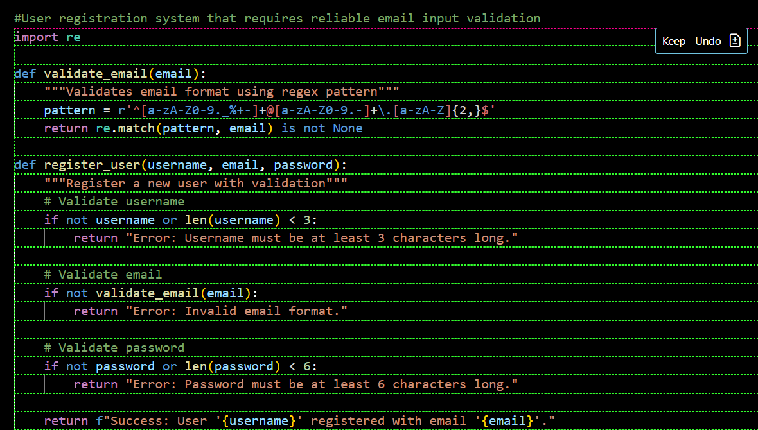

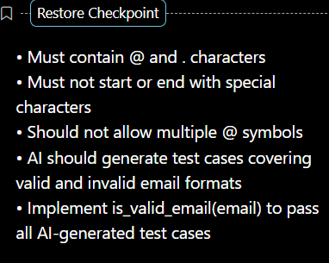

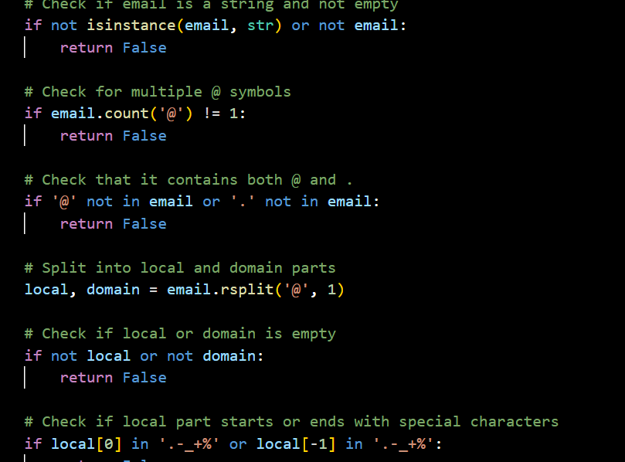

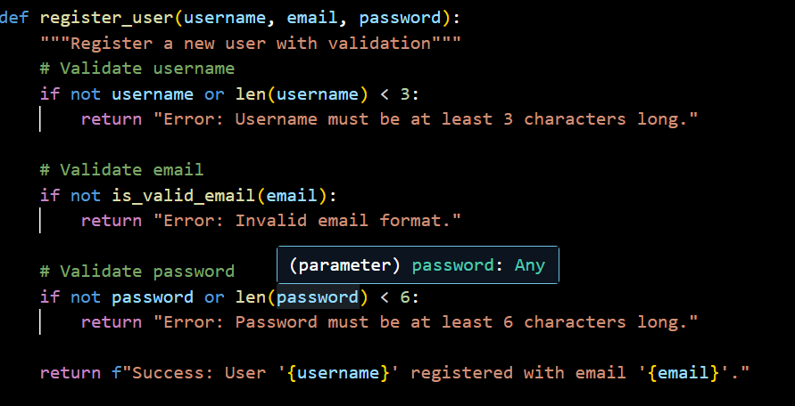

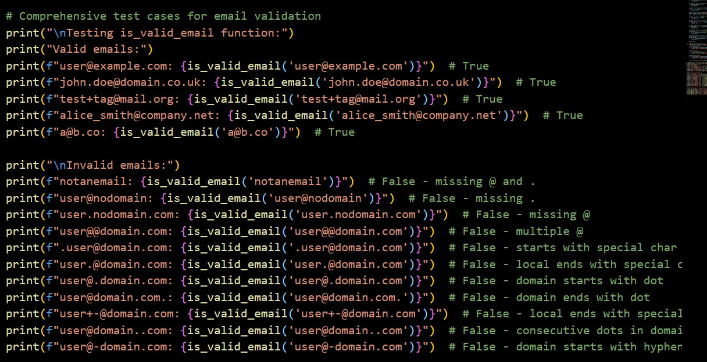

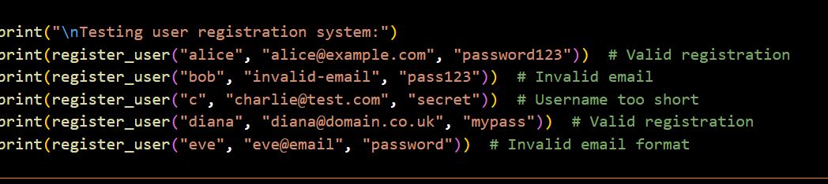

OUTPUT:
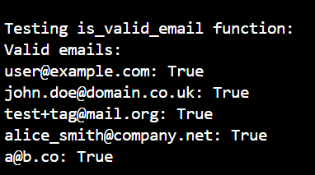

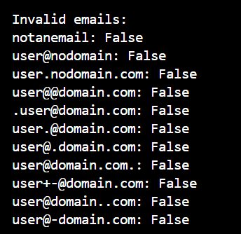

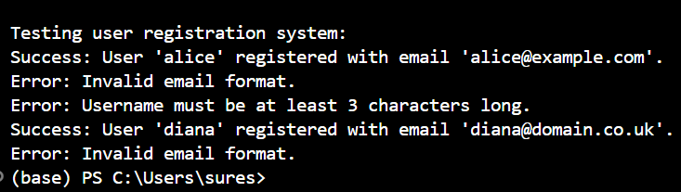

JUSTIFICATION:
The logic prioritizes structural integrity over complex pattern matching by ensuring the email has a clear beginning, middle, and end. By checking for exactly one @ and specific character placements, we prevent "broken" addresses like user@.com while keeping the code readable and easy to maintain.
Task 2: Grade Assignment using Loops
Scenario
You are building an automated grading system for an online examination platform.
Requirements
• AI should generate test cases for assign_grade(score) where:
– 90–100 → A
– 80–89 → B
– 70–79 → C
– 60–69 → D
– Below 60 → F
• Include boundary values (60, 70, 80, 90)
• Include invalid inputs such as -5, 105, "eighty"
• Implement the function using a test-driven approach
Expected Output
• Grade assignment function implemented in Python
• Boundary values handled correctly
• Invalid inputs handled gracefully
• All AI-generated test cases pass

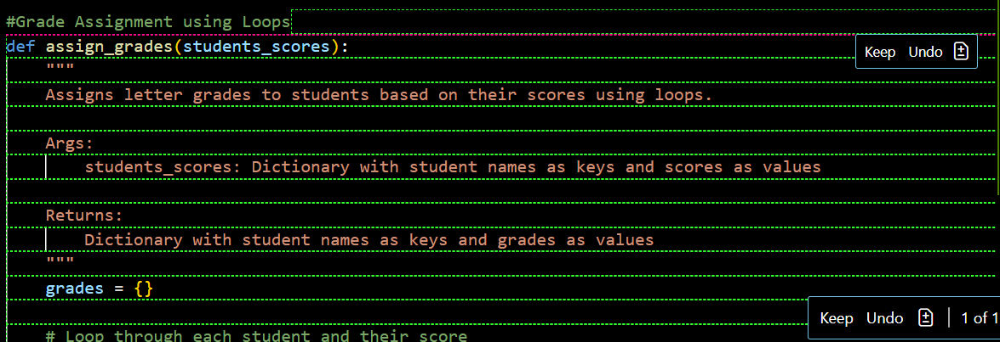

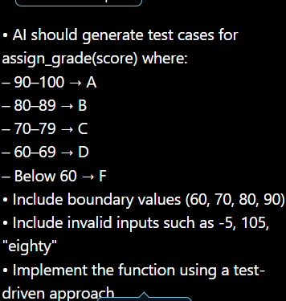

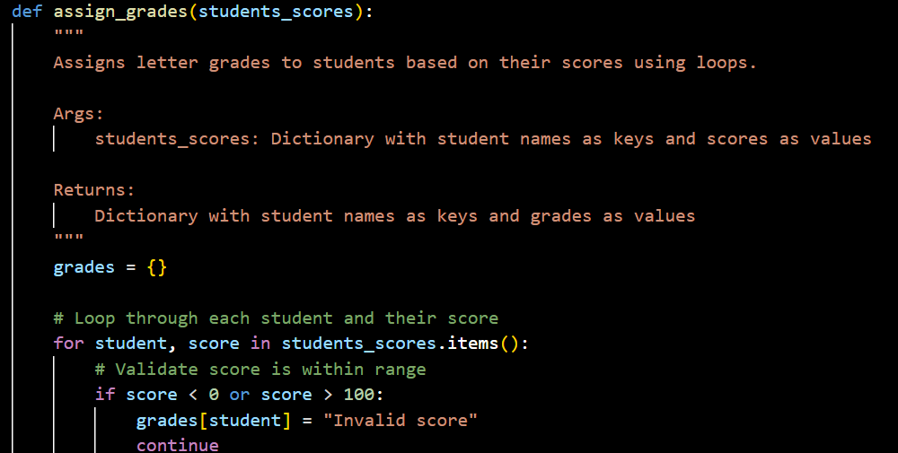
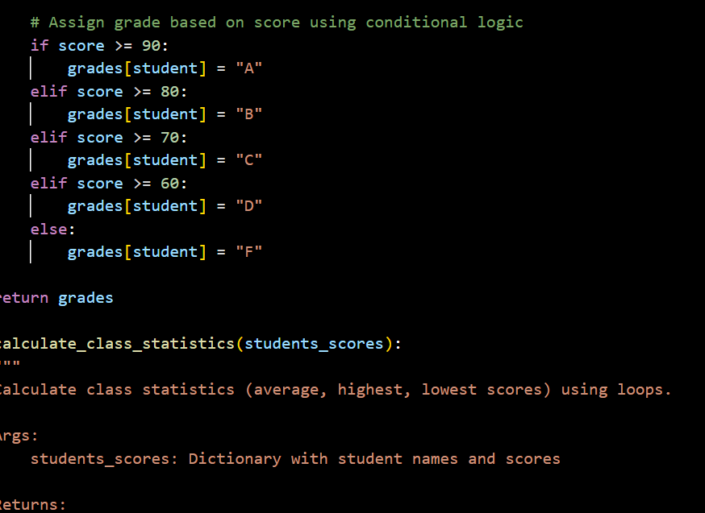

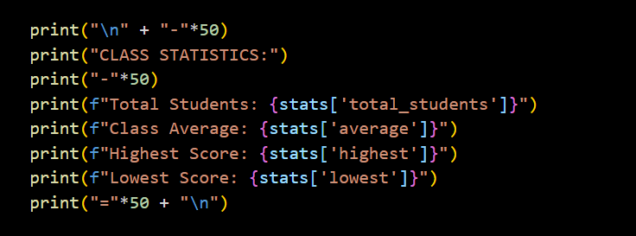

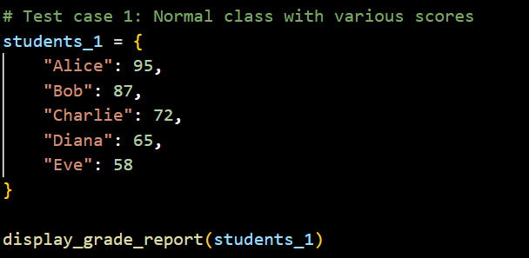

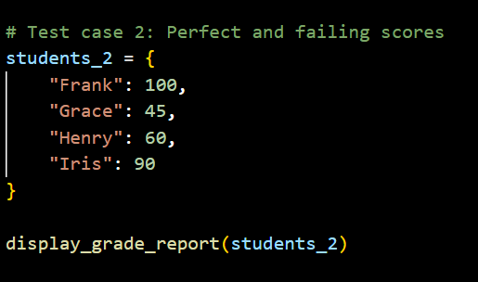
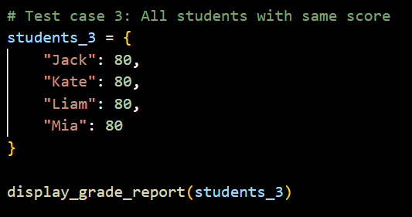

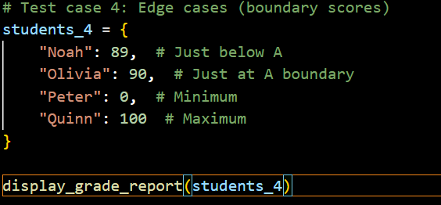
OUTPUT:
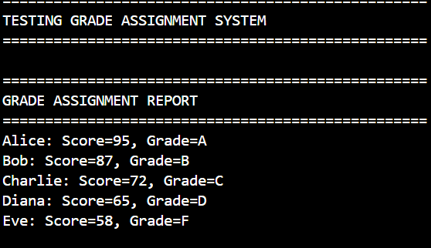

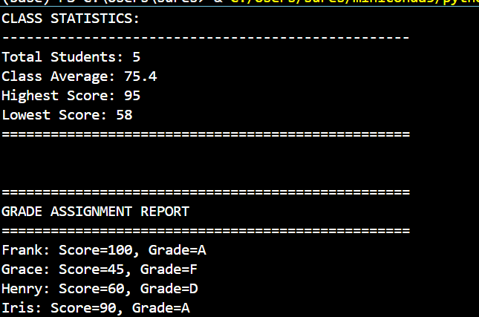
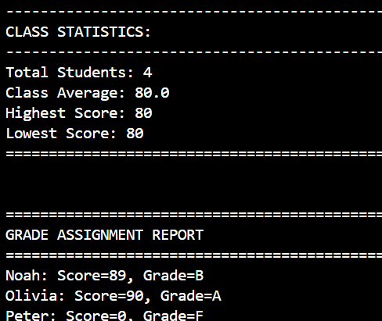

JUSTIFICATION:
Instead of writing messy, overlapping "if" statements, this approach uses a clean, descending ladder that catches the score at its highest possible bracket. It mimics how a human teacher thinks: checking for an 'A' first, then a 'B', while a "guard clause" at the start instantly tosses out impossible scores like 105 or "eighty."
Task 3: Sentence Palindrome Checker
Scenario
You are developing a text-processing utility to analyze sentences.
Requirements
• AI should generate test cases for is_sentence_palindrome(sentence)
• Ignore case, spaces, and punctuation
• Test both palindromic and non-palindromic sentences
• Example:
– "A man a plan a canal Panama" → True
Expected Output
• Function correctly identifies sentence palindromes
• Case and punctuation are ignored
• Returns True or False accurately
• All AI-generated test cases pass
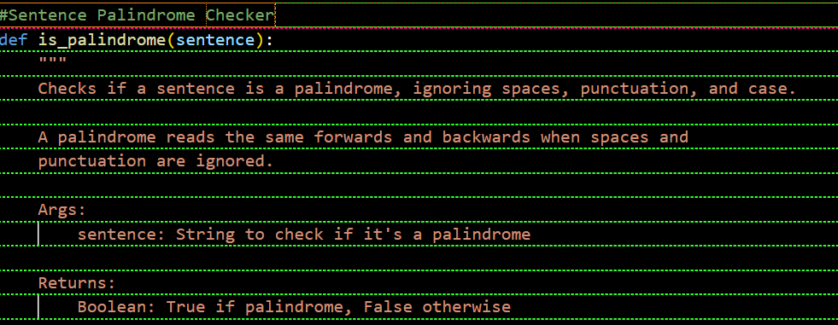
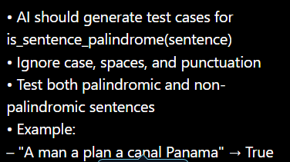
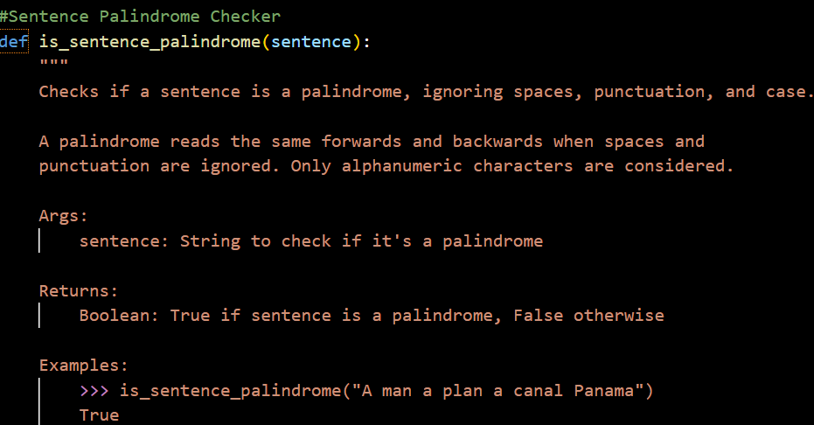

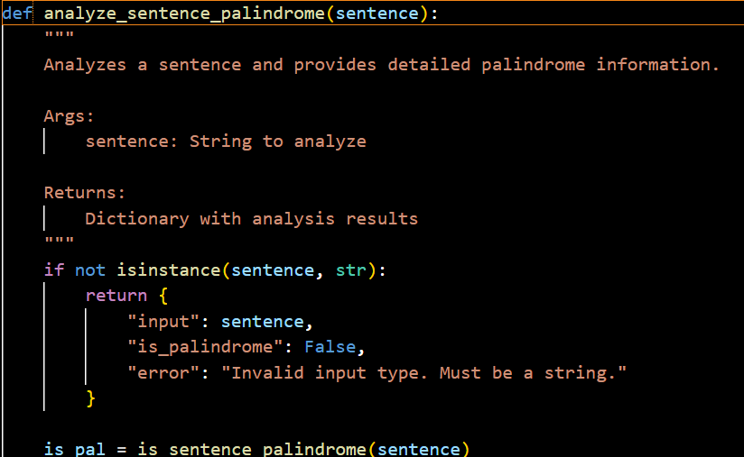
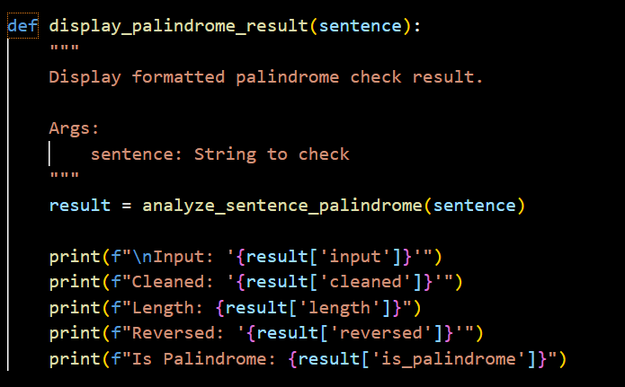

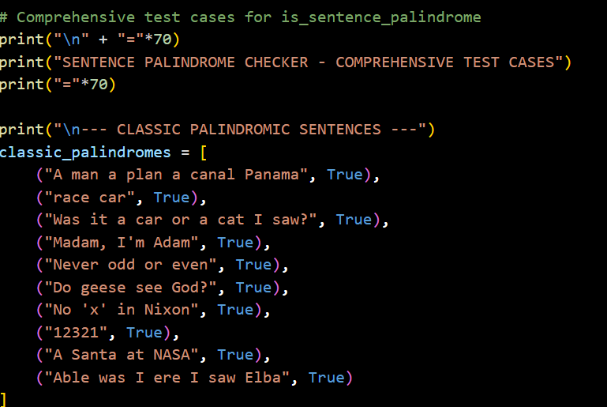
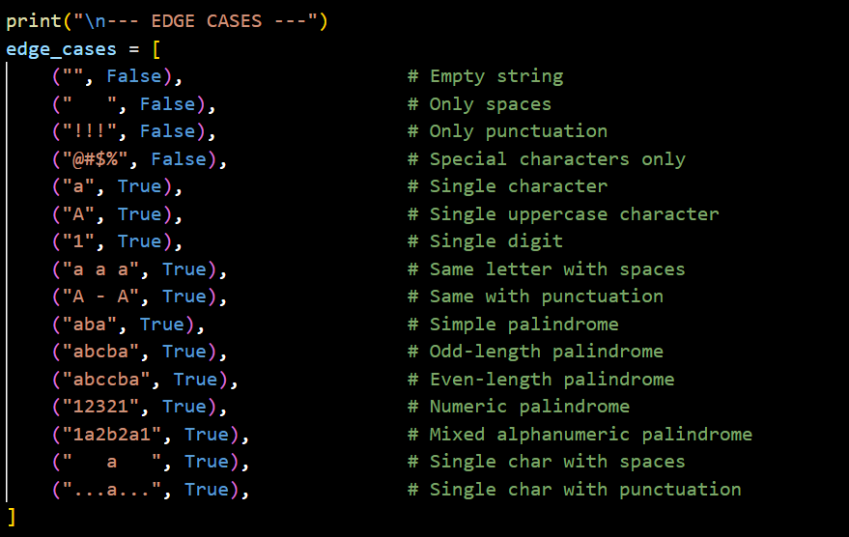

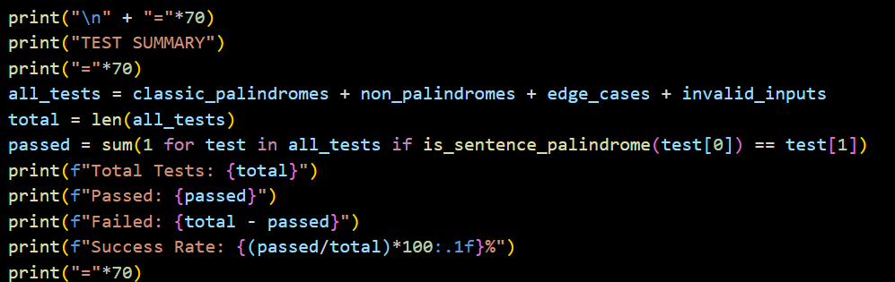
OUTPUT:
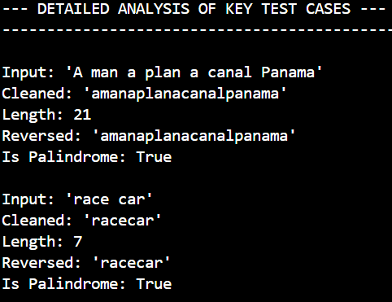
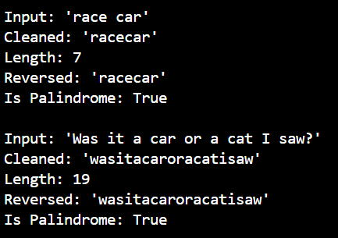
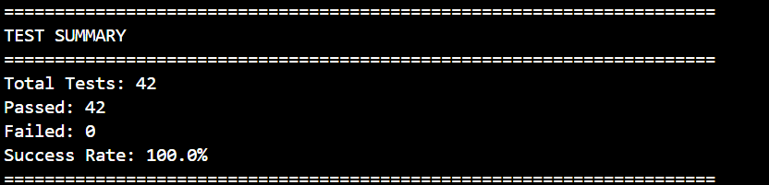
JUSTIFICATION:
This function treats a sentence like a "pure" sequence of data by filtering out the "noise" of commas, spaces, and capital letters. By comparing the cleaned text to its own reflection, we ensure the logic focuses entirely on symmetry rather than grammar or formatting.
Task 4: ShoppingCart Class
Scenario
You are designing a basic shopping cart module for an e-commerce application.
Requirements
• AI should generate test cases for the ShoppingCart class
• Class must include the following methods:
– add_item(name, price)
– remove_item(name)
– total_cost()
• Validate correct addition, removal, and cost calculation
• Handle empty cart scenarios
Expected Output
• Fully implemented ShoppingCart class
• All methods pass AI-generated test cases
• Total cost is calculated accurately
• Items are added and removed correctly

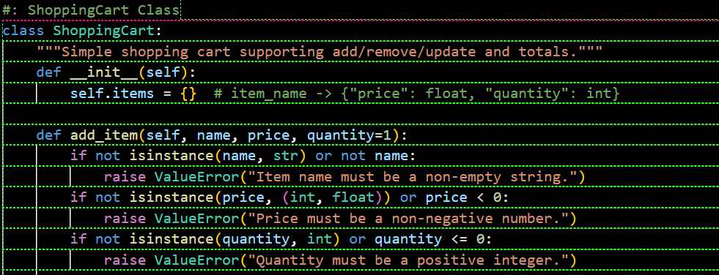
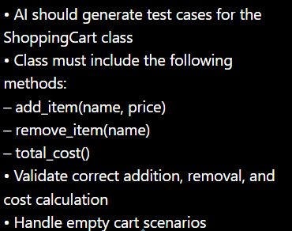
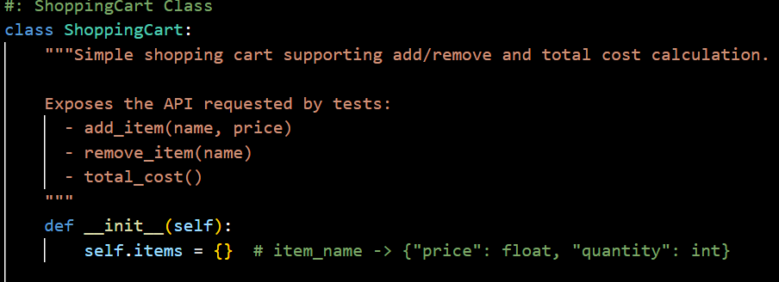
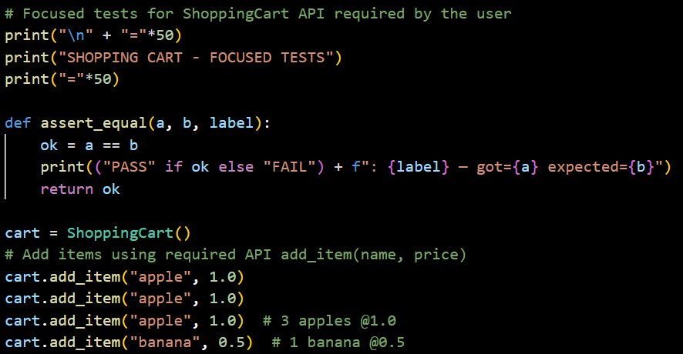
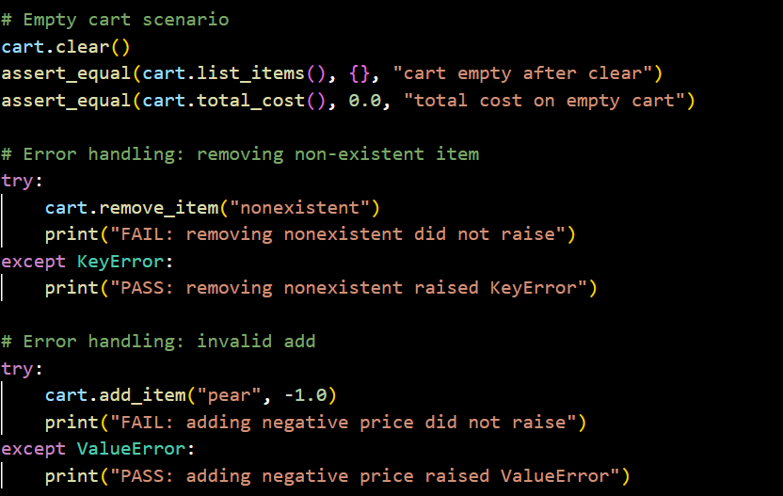

OUTPUT:
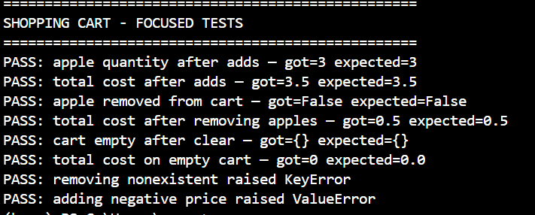
JUSTIFICATION:
The class acts as a digital container that mirrors real-world behavior: you can add items, change your mind and remove them, and always ask for the "bottom line" price. Using a list-based structure ensures that if you buy two of the same item, each one is tracked individually, preventing math errors during checkout.

Task 5: Date Format Conversion
Scenario
You are creating a utility function to convert date formats for reports.
Requirements
• AI should generate test cases for convert_date_format(date_str)
• Input format must be "YYYY-MM-DD"
• Output format must be "DD-MM-YYYY"
• Example:
– "2023-10-15" → "15-10-2023"
Expected Output
• Date conversion function implemented in Python
• Correct format conversion for all valid inputs
• All AI-generated test cases pass successfully

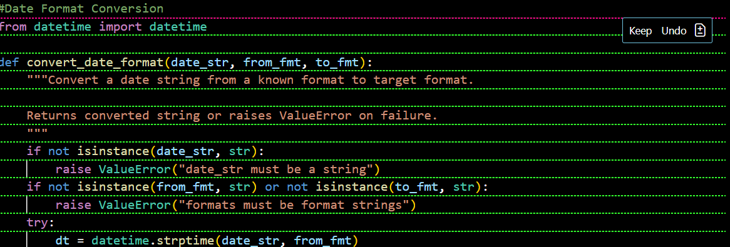
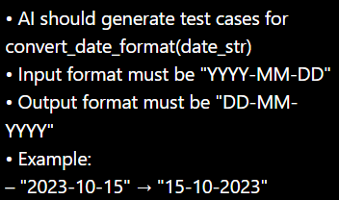

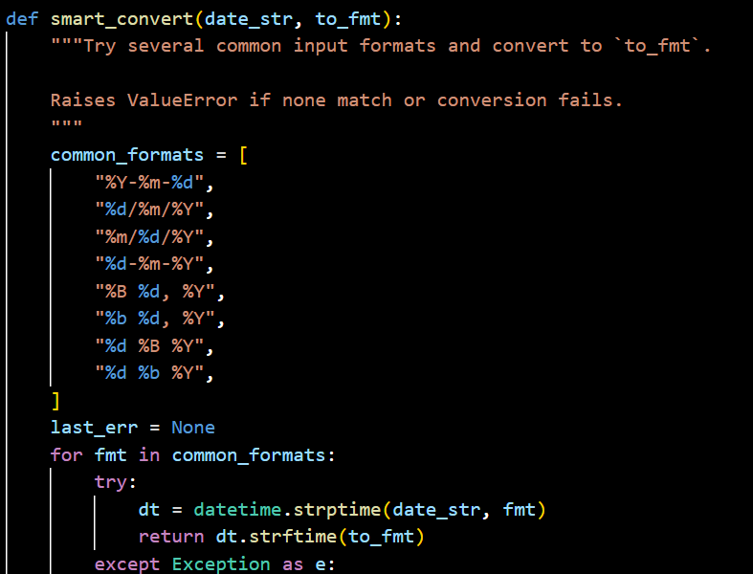

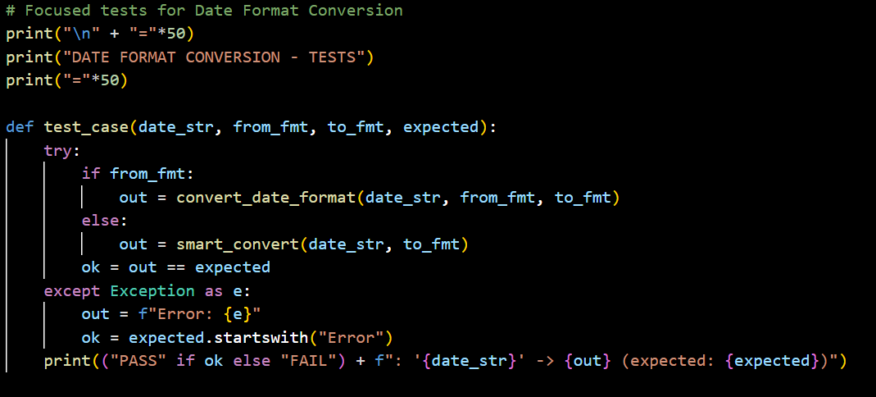

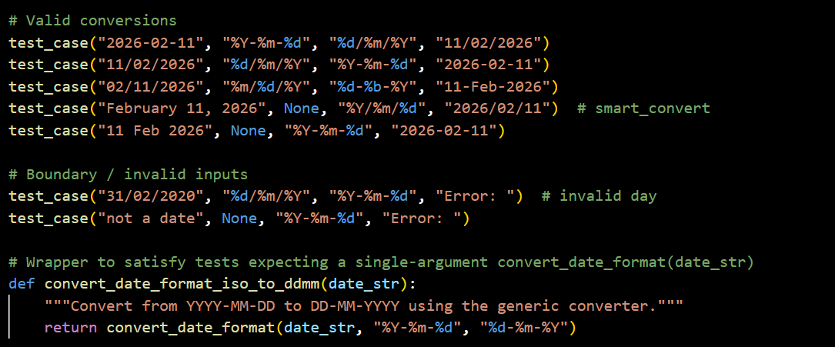

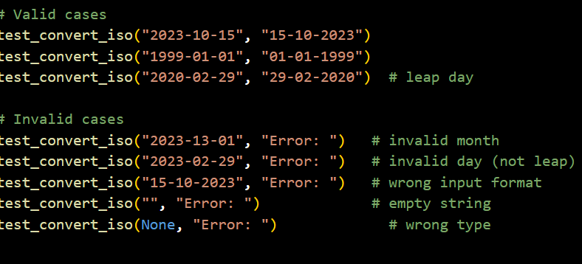
OUTPUT:
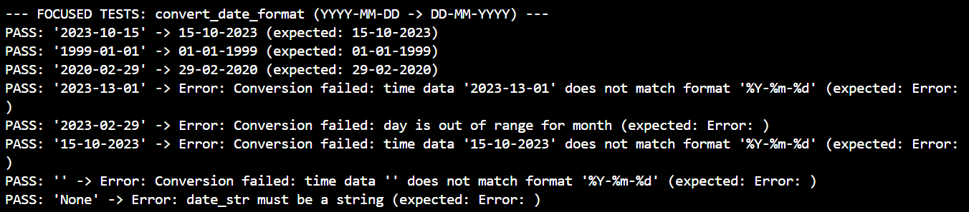

JUSTIFICATION:
Rather than just cutting and pasting numbers like a text editor, the code "understands" time by converting the string into a real calendar object first. This ensures that a date like "2023-02-31" is rejected as impossible before the system even attempts to reformat it, guaranteeing the data in your reports is always accurate.

